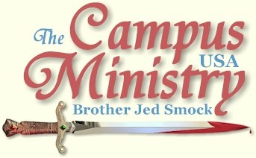
brojed@aol.com
brojed.org
573-999-0347 begin_of_the_skype_highlighting 573-999-0347 end_of_the_skype_highlighting
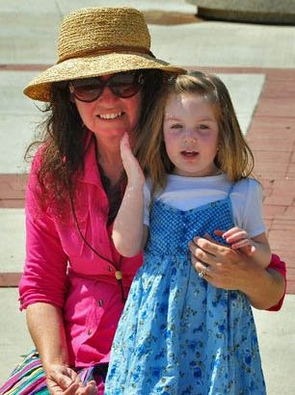
Iris Quotes Psalm 1-See Below
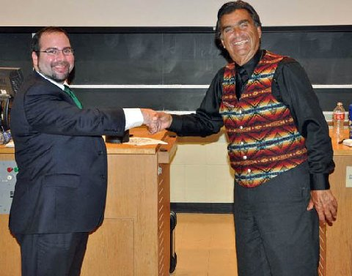
Read About the Great Debate Below--over 220 Students and Professors attended!
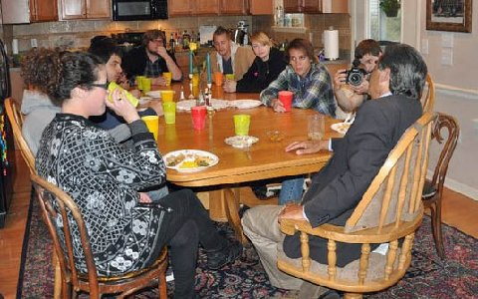
Our Semi-Annual Dinner/Open House for the Students on Friday Was Very Fruitful!

Wild Day
Truman State University, April 11, 2011
Two pretty girls, who turned out to be lesbians, were the first to stop and sit down. One had a boy’s hair cut. Both were personable. Others soon joined and for the first hour I had a quiet time with about 12 students.
At one point, I asked several who were critical if they were Christians. A girl affirmed that she was a Christian. A boy standing beside her said, “I did not know that you are a Christian.”
I asked him, “Do you know this girl?”
He answered, “Yes.”
I said to the girl, “You are a sad case; here we have a man who is your friend and he does not even know you claim to be a Christian.” I have to wonder about the Christianity of people whose friends do not know that they are Christians.
During Bro’s hour the crowd grew considerably. During my second stint with so many professing lesbians and homosexuals in the crowd, I delivered my lecture, Sex Ed with Brother Jed. I also told my testimony. Students were spirited but not particularly hostile. One fellow asked, “Are you a court jester or a preacher?” I asked him, “What do you want to discuss?” “Theology,” he answered. “Good,” I said. “Most of these people seem to want to talk about is sex all the time.” We got into a discussion about the foreknowledge of God.
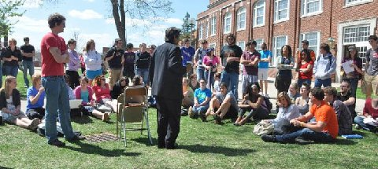
"I also told my testimony. Students were spirited but not particularly hostile."
During Bro’s next session things began to heat up. He was preaching holiness. Bro had an encounter with a girl whom he had seen in a poster on campus wearing a t-shirt which said, “Jesus Can Set You Free from the Power of Sin.” But in the crowd today she was defending sin, claiming no one is perfect.
Several sincere students meanwhile were asking me questions. One girl mentioned that in my Sex Ed lecture I said nothing about masturbation. I informed her that it was sin. Another girl asked, why have you not been speaking of God’s grace?” Much to my surprise she accepted my answer that law must precede grace in our call to salvation from sin.
At one point Bro rebuked a lesbian, who claimed to be a Christian. She was comforting a lesbian whom Bro had offended earlier by referring in explicit terms to what lesbians do. The one being comforted then physically attacked Bro and some people in the crowd had to restrain her. During this time, I had 12-15 sober students around me asking good questions, especially dealing with Christian perfection. Since Bro’s crowd was becoming volatile, he walked away from those that were raging.
Since it was 5:30, I announced, “We are leaving. We may return next Monday. God loves you and so do we.” Several students thanked us for coming today despite all the commotion which had resulted from Bro calling the lesbians on what they do.
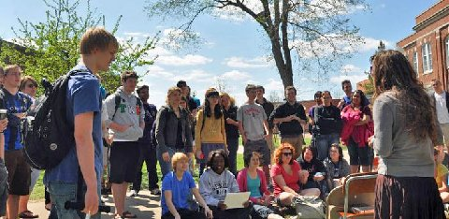
Martha Marie at Truman State in Missouri
HOWL
University of Missouri, April 12, 2011
“This is the best day we have ever had at Mizzou,” concluded Bro Cope at the end of the day.
Bro started off teaching on a variety of subjects especially creationism, to an attentive crowd.
Cindy introduced granddaughter, Iris, 2, to the crowd and she quoted Ps. 1. She then quoted John 3:16 while holding a crucifix. I heard a girl say as she was quoting this verse, “She does not understand what she is saying.” Martha defended Iris saying, “Iris is real smart whenever she sees the crucifix she says, “He hurt.”
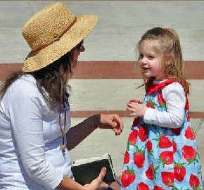
Iris Quoting Psalm 1
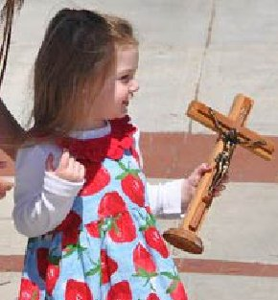
"He Hurt"
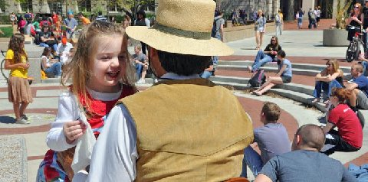
"Trot Trot To Boston Game" with Grandfather while Martha Preaches
For my one and only turn I spoke from John 18 when Jesus was on trial before Pilate and he said unto the governor, “For this end was I born and for this cause I came into the world to bear witness to the truth. Everyone who is of the truth hears my voice.” I spoke on the nature of truth for an hour and how we could know that Jesus is the truth.
A Moslem wanted to know how we pray. I pointed out to Christians prayer is not a matter of form and posture but a matter of the heart. He asked, “What might a Christian pray?” I answered the Lord taught us to pray after this matter. I took off my hat and bowed my head and prayed the Lord’s Prayer. I notice it was very quiet as I prayed.
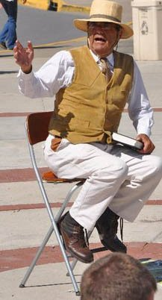
A Muslim asked, "How do you pray?"
Rocket spoke for about 30 minutes and 4-6 students followed him to the outer Circle after he turned the meeting back to Bro Cope. Rocket later reported he had an outstanding time of Q&A with them. Bro had a confrontation with a lesbian, who then started reading at the top of her voice from a book on the purpose of music.
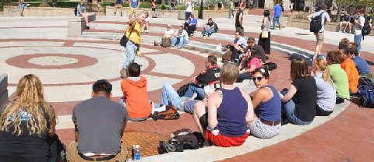
After his preaching time, Rocket had a great question and answer session with several students.
Bro turned the meeting to Sister Cindy. A boy started reading Allen Ginsburg’s “Howl,” which is a decadent work of poetry from the “Beat Generation,” of the 50’s which celebrates madness, homosexuality and drug addiction, all of which became commonplace in our society a half century later. Another boy was walking around in a circle muttering. A group of students sat right in front of Cindy smoking from a Hookah. One of the smokers encouraged others to talk and try to distract Cindy. He said, “We need to take back the Circle from these religious people.” Ginsburg taught that we do not need a Supernatural Jesus. Meanwhile, Cindy was standing center Circle boldly reading the Bible. [Sometimes one needs simply to hold her ground.] Meanwhile the one reading “Howl” admitted to me that after finishing the poem that he was losing his voice. “I do not know how you do it,” he said to me. By now the lesbian was reading a book by a lesbian author. Finally a man roared his motor cycle for several minutes in the Circle. Cindy later said, “That was a good illustration of all that they stand for is noise.” Reading from “Howl” was also good symbolism of the emptiness of their lives. They howl like animals instead of speaking rationally like humans. They will not be able to take back the Circle because they really have nothing to say of consequence. Ginsburg would have relished being a part of the scene. Of course, he has been howling in Hell for about 14 years now along with Jack Kerouac, William Burroughs and Lawrence Felinghetti. When one rejects truth they hear the voice of the devil.
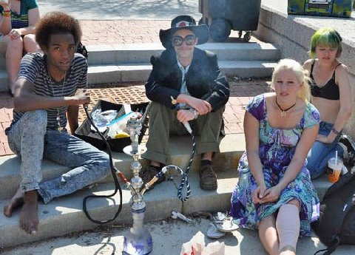
Students Smoking Hookah
During this time Bro was having a penetrating conversation with a girl who was under deep conviction. We left campus about 5:30.
A DISORDER OR A DIFFERENCE?
University of Missouri, April 13, 2011,
I started the meeting today and soon gathered a crowd. Then I turned the meeting over to Bro after 40 minutes. My second session I spoke from John 7:17, Jesus said, “My doctrine is not mine, but his that sent me. If any man will do his will, he shall know of the doctrine, whether it be of God, or whether I speak of myself.”
Ultimately, to be convinced of the truth claims of Christianity one must do God’s will, which means walking in the light that one has through nature, conscience and through Biblical revelation. When men reject the light that is within, they fall into darkness and unbelief. In the realm of science one must do the experiment, if one repeatedly gets the same results then he may conclude that he has established a scientific truth. When one practices God’s ways, he will discover that his ways work.
At one point Rick, who usually preaches on Wednesdays and with whom I have been having conflicts since we moved to Columbia, interrupted me to expound on salvation being all of God and our works have nothing to do with salvation. He taught that even a Christian cannot keep the commandments of God for even a day. I read to him from James 2, but he refused to hear it. I have gone over these arguments many times with Rick.
Cindy arrived with Sister Pat and Iris so I turned the meeting over to Cindy; she spoke twice and Pat preached once.

Psalm 1: Blessed is the man that walketh not in the counsel of the ungodly...
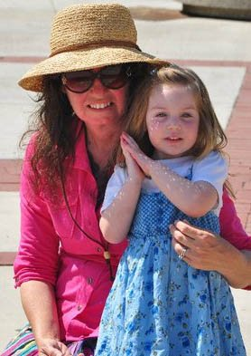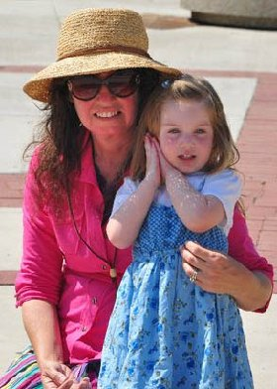
"...In His Law Doth He Meditate Day and Night..."
Go to: http://www.facebook.com/brojed/posts/10150163104843917?ref=notif&notif_t=like#!/video/video.php?v=10150110097083798
to see a video of Iris quoting Psalm 1
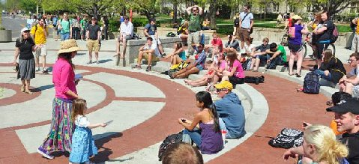
Iris helps Grandmother pass out invites to our Semi-Annual Open House/ Dinner
I noticed that the boy (Mark), who was walking in a circle and muttering to himself during the chaos yesterday, was sitting on the wall. I asked him, “Why did you behave like you did yesterday walking in a circle and muttering to yourself?” He assured me that he was not mocking me or trying to detract from what I was saying but that he was bored and needed exercise. He explained that he had been bullied a lot when he was in elementary school and had few friends. I quoted Proverbs 18:24, which teaches a man who will have friends must show himself to be friendly. He told me that he had been diagnosed with a form of autism called the asperger disorder. I raised the question should the symptoms associated with this diagnoses be considered a disorder or a difference from what is considered the norm. We discussed this at length. Finally, a psychology major who must have overheard our conversation began to question me concerning my views on psychology. He had obviously heard me expand on the subject before. We had a long conversation. I pressed him on the standard to determine normal human behavior. I explained that Jesus Christ is the standard of correct social behavior. Yet, he was quite different from his peers. It is interesting to note that the second part of Proverbs 18:24 reads, “and there is a friend that sticks closer than a brother.” Who would that friend be, but our Lord Jesus Christ, who will comfort us in all of our afflictions?
I do not usually approach students on the sidelines. But today I sensed a strong leaning to inquire of Mark concerning his behavior. It developed into a profitable session with him and the psychology major. I concluded that I need to take more initiative to approach students on the sidelines, especially when I am with two to three other speakers. Of course, often I am busy on the sidelines since students frequently approach me.
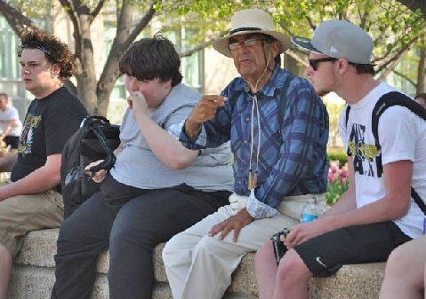
Sideline Discussions at Mizzou
During my last session in the Circle, we discussed ethical issues such as the difference between murder and justifiable homicide. A soldier who had served in combat in Iraq followed me back to the car. He was concerned about these questions. He spoke how some of his friends had lost their faith during the war over some of the things they saw and perhaps were required to do. I reminded him how the soldiers of Israel had to do some terrible things in defeating God’s enemies in Canaan. I said as horrible as things may have gotten in Iraq, there was never anything as horrifying as the slaughter of the men, women, children and babies of the heathen of Canaan by the army of Israel. He was visibly moved by our conversation and expressed an interest in pursuing these things on another day.
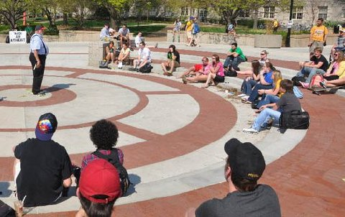
Bro Cope does a great job with the Creation/Evolution Issue
THE DEBATE:
Is Christianity True?
University of Missouri, April 14, 2011
Bro and I held forth in the Circle until 3:30. I left early to get some rest before the debate. Sister Cindy and Sister Pat arrived after I parted and they preached for a couple of hours. In my two sessions I concentrated on points which I planned on bringing forth during the debate in order to test my arguments.
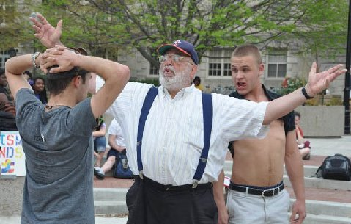
The devils were really stirred up before the debate but Bro stood firm.
For the debate we filled the lecture hall in the Engineering Building with students and professors. Around 220 people attended. The atheist club, which sponsored the debate, did a good job of promotion. Both the city paper and the student paper, The Maneater, had done a story promoting the debate. The Maneater was present to cover the event with a reporter and photographer.
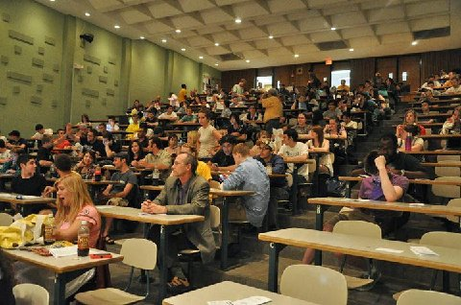
This photo was taken about ten minutes before the debate started. Not only did all the chairs fill up but they were standing 3 people deep in the back.
The question for debate was “Is Christianity True?” I opened with Jesus saying to Pilate,”To this end was I born, and for this cause came I into the world, that I should bear witness unto the truth. Every one that is of the truth heareth my voice.”—John 18:37. And, “If ye continue in my word, then are ye my disciples indeed; And ye shall know the truth, and the truth shall make you free.”—John 8:31-2
Truth must be presupposed or one cannot know or prove anything at all. My opponent, Dave Muscato, who refers to himself as a global skeptic, admitted that you cannot know or prove anything.
I emphasized that one must know the fundamental doctrines of Christianity, or one cannot make an intelligent decision as to whether or not the teachings are true. With so few students having even read a significant portion of the Bible, they cannot know if Jesus’ teachings are true because they do not know what they are supposed to believe. The evidence that Christianity is true is that it works. A hypothesis is verified when it smoothly interprets life. Christianity provides reasonable, consistent and coherent answers to the basic questions of life concerning the origins of the universe and man, the meaning of life, our moral foundation and it gives us a reasonable hope for life beyond the grave. Christianity gives man dignity and purpose.
In the physical realm men need three things in order to survive, food clothing and shelter. We are also spiritual beings and to be healthy mentally we need three things, faith, hope and charity. Just as there are clearly opportunities, with a little bit of work, to satisfy our physical needs; it stands to reason that there are opportunities to gratify our spiritual needs, but only through the faith in Christ, which makes men whole.
During the cross examination period, I asked my opponent how he would answer the metaphysical questions concerning origin, meaning, morals and destiny. He admitted that atheism did not have the answers. I countered, “If one has a philosophy which offers no answers to fundamental questions, then one ought to discard the philosophy and search for a world view which offers answers. Atheism is irrelevant. The evidence that Christianity is true is that it is relevant and life transforming.
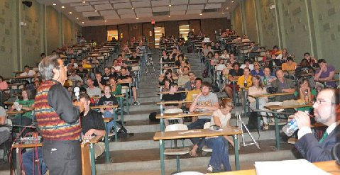
Many stayed for the Question and Answer period.
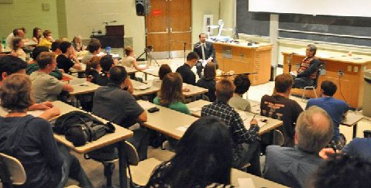
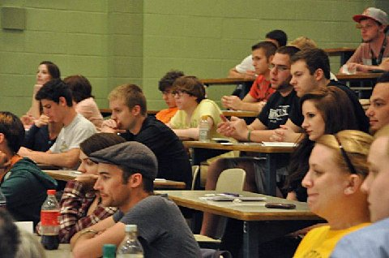
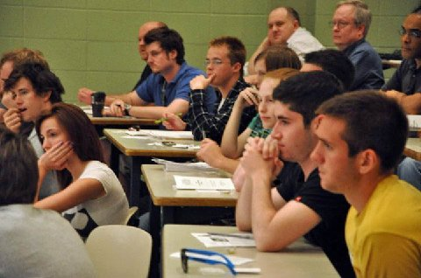
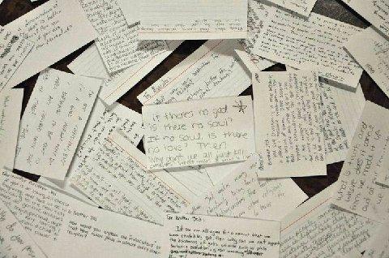
Questions that students wrote for the debaters.
The debate lasted for almost two hours including Q&A from the audience. The event was filmed, which we hope to get posted on YouTube in the near future.

THE OPEN HOUSE
University of Missouri, April 15, 2011
Sister Pat and I went out on a cold, cloudy and windy day after it had been raining most of the morning. It was about a 20 degree drop in temperature from yesterday. Bro stayed home to help Cindy with the cooking and Martha did not arrive until later because she had been working on house cleaning. Pat was able to draw a crowd of about a dozen primarily by questioning a boy concerning his views on sodomy. He had no problem with it and admitted to practicing it with the opposite sex.
During my turn, I maintained about the same number with students coming and going. A group of high school students sat down, who were on campus for a debate contest. The issue of the debate was whether or not drug offenders were to be treated criminally or medically. I had good dialogue going on that subject until a college student got involved in arguing with the high schoolers, meanwhile others in the crowd started talking among themselves. I soon realized that no one was listening to me. Therefore, I stopped preaching. However, I am the fire, which kindles the conversation and within minutes the heat was gone so everyone left.
Sister Pat started again at the next break. Meanwhile, I was conversing with a brother named, Will, concerning last night’s debate. He argued that had he been debating he would have said from the beginning that he could not prove Christianity because faith is contrary to reason. I pointed out that we could give evidence which should be convincing proof for truly open minded men, which is why Peter said, “Be always ready to give an answer (reasoned defense) for the hope that is in you.”—1 Peter 3:15. And Isaiah said, “Come let us reason together.”—Is 1:18.
By 4 PM Sister Pat was conversing with just one student. I had offered Jon, the gay guy, a ride to our open house. Jon is a likeable fellow. We arrived home at 4:30, an hour before dinner time. Already one other student, Patrick, had arrived. He rode his bicycle to our home. Aaron, a communication major, arrived early to make a documentary on our event for a class project. Jon helped Cindy put the rolls on the table. She made sure that he washed his hands first.
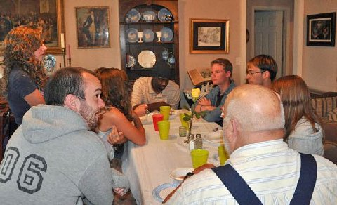
Jon is in the center on the right side.
Patrick, an atheist, had all sorts of questions. He was not argumentative. Emily, another atheist, stood by listening to our conversation. This set the tone for the evening; I defended the faith in most of my talk with students. None were contentious.
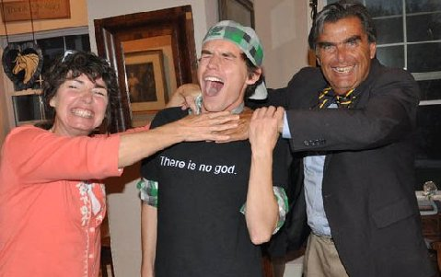
Patrick an atheist wore his "no god" shirt.
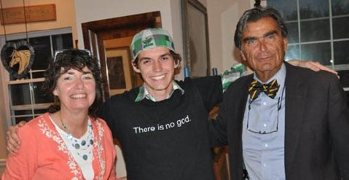
Thirty students attended our open house and several homeschoolers. Many of them commented on how nice a home we have, which we could not have without the faithful support of our partners in the ministry who give generously to our mission. Cindy thought that they were just happy to be in a homey place. Most who attended were unbelievers, including the gentleman whom I debated. We had spiritual and edifying conversation throughout the evening. As with the crowd at the debate, the students who came to our home were civil and seemed to thoroughly enjoy themselves. They especially appreciated Cindy’s cooking which consisted of turkey, roast pork, potato casserole, mashed potatoes, gravy, fresh green beans and corn, Greek salad, rolls, freshly baked cookies and brownies, a tri-fresh fruit desert, lemonade, sweet tea and other odds and ends. If the old saying is true that “the way to the heart is through the stomach,” then we touched many hearts.
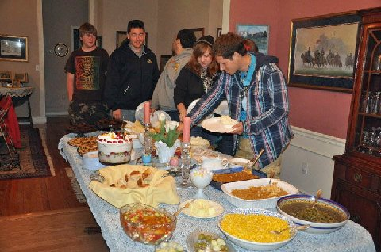
Special thanks to Sean Steuber, Sister Pat, Bro Cope, Priscilla Smock, Martha Smock, Shelby Butterworth and Nolan and Morgan Steuber who worked many hours to help get everything ready. (Bro. Jed got the yard ready:)
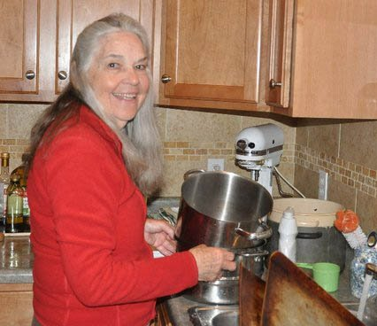
Sister Pat washed a lot of dishes!
Cindy had a long conversation with Aaron, Rachael, and she does not remember the name of the other boy. They described themselves as “spiritual but not religious.” They wanted to know why we were so different in our home compared to the way we were on campus. They understood Cindy’s answer and they concluded that they liked our approach; it got their attention. They also asked Cindy good questions about the Bible and how to interpret it.
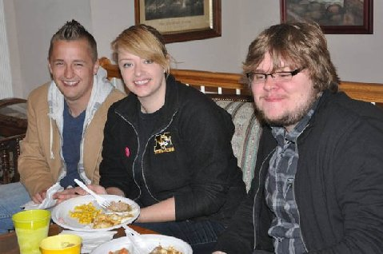
"We are not religious but spiritual." They concluded that they really like our approach to evangelism because it made them think about God.
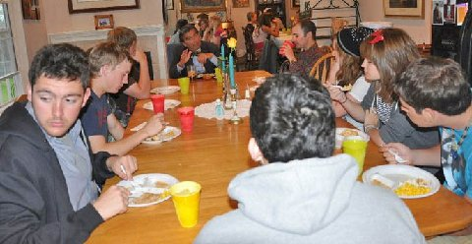
We had two extra tables set up in the living room, but still had to pull up some extra chairs.
We really had some great conversations!
Two non-students, Jordan and Chelsea, who live together, heard of the debate over facebook. They attended the debate where they heard about our open house. Each of them sat beside me while I was eating. Jordan thought that my performance at the debate was “amazing.” Many commented positively concerning my speaking skills. Of course, I have had more experience speaking then other men. But the key to being a good speaker is to have a message which one fervently believes.
Dave Muscato and I rehashed some of our debate points, which the students enjoyed hearing again. Everyone lingered for a while after eating, some for a few hours. The last one to leave was Aaron, the filmmaker, who confessed that I had rebuked him for his fornication when he first arrived as a student at Mizzou. But he was not “turned off.” He said he listened for three hours that first day. And he has listened many times since. He now has hours of video footage to listen to of Cindy and me conversing with the students in our home. He plans on putting his film up on YouTube.
We had a lot of prayer backing for the last two night events. I sensed a powerful presence of the Holy Spirit during the debate and open house. All, who attended these events, will not forget that they have been given reasons to have faith in God.
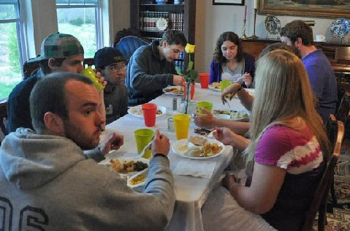
Justin, the Mizzou student in the gray T-shirt has been taking advantage of the opportunity to witness to his fellow students on the sidelines each day this week. He said that it took him a while to realize that this was much wiser than trying to oppose the preaching.
Bro. Jed's Schedule
April 19, University of Central Missouri
April 20-22 Missouri State University
April 25-Truman State
April 26-29 University of Missouri
May 2-5 Southeast Missouri State
May 9 University of Central Washington
May 10-13 Eastern Washington State
May 16-20 University of Washington and Western Washington
May 23-27 University of Oregon
June 31-June 3 University of Washington and Western Washington

Thank you for your faithful prayers and support. Please continue to pray for us. You may donate to CMUSA using PayPal by going to our web site brojed.org or by mailing your check to our home address: CMUSA 2402 Longview Dr. Columbia, MO 65203. All gifts are tax deductible. Thank you for your generosity.
Ministry Needs
1. Lots of Prayer
2. Money for a 5 day trip to Southern Missouri this week...gas will be the main expense. Our team will include, Bro. Jed, Martha, Bro Cope, Sis. Pat and Sis. Cindy
3. Safety on the Road and Good Health
4. Wisdom and Anointing
5. Money for the upcoming 5-week trip that Bro. Jed and Martha Marie will make to Oregon and Washington in May. There will be lots of travel expenses!
6. Money for the update of our web site. A friend has our site updated and Martha has added a lot of the journals and pictures from this year. There was an added cost to fix the site.
7. Tell your friends to check out the website.
8. Lots more PRAYER!

