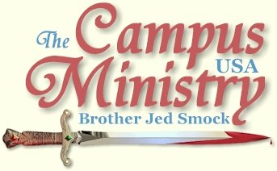
brojed.org
(check out our updated site!)
brojed@aol.com
cell 573-999-0346
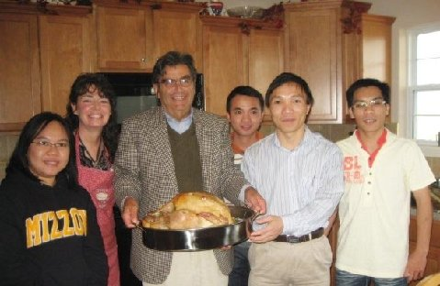
Our 23 pound turkey was the first turkey that these
Vietnamese students had ever seen!

WILD ASS’S COLTS
University of Kansas, November 23, 2009
We had a nice break in the weather, low 60’s and partly sunny. I drove West on I 70 from Columbia to Lawrence. I made a wrong turn and consequently got in on the end of the noon break. Nevertheless, I was soon able to gather the attention of 20-25 students, which was my average size crowd throughout the afternoon.
When I confronted the careless and profligate sinners with my new sign picturing their licentiousness and other immoral acts, they responded with ridicule. So I countered with “a whip for the horse, a bridle for the ass, and a rod for the fool’s back (Proverbs 26:2).”
Initially, they were a lewd bunch; so for a time I answered the fools according to their folly by demonstrating the stupidity of sin out of my own college experiences. Later I did not answer them according to their folly. I reasoned with them showing the consequences of their naturalistic presuppositions.
“No wonder you believe in evolution, and think that you are animals. You act like and live like animals. Like brute beasts, you are governed by your natural instincts and physical appetites. Therefore, you have concluded that you must be an animal. Should you ever choose to be governed by reason and conscience as you were designed, you will understand that that you are a unique creation made in the image of God.”
A female atheist (former Episcopalian), who was present all afternoon demanded empirical evidence for the existence of God. I replied, “We study the physical world with our five senses. The empirical method is the tool of your physical sciences. Tools for knowing God include faith, reason, intuition, experience, and the authority of the Bible. God is a metaphysical being. The prefix “meta” mean beyond. God exists beyond the physical world. We do not perceive him through our physical senses. We perceive him through faith; but I can give you reasons to believe. God’s existence is a self-evident truth. Creation testifies to a Creator like the statue requires the sculptor. God came to earth and men touched him; but he went back up into Heaven and sent his Holy Spirit back to earth. The Spirit is like the wind; we see its effect; but we do not see it. Read the Bible it is God’s revelation of himself to man.”
She claimed that she had read the Bible. I asked, “What is the basic theme of the Bible?
“Murder and mayhem from God,” she replied.
“Let me clarify my question, what does Christianity teach is the basic theme of the Bible?”
She did not know; so I answered my own question, “The theme of the Bible is God’s revelation of himself to man through his Son Jesus Christ.”
“What about dinosaurs?” some lame brain asked. [Throughout the afternoon each day I am asked about dinosaurs several times. I do not understand the world’s fascination with these creatures; I suspect what most of students claim to know about dinosaurs is based more on science fiction than true science. They have seen Jurassic Park or Barney and think they know something.]
“These giant reptiles called dinosaurs are not relevant to the theme of the Bible. Big reptiles, little reptiles, they are insignificant in the light of God and his revelation to man through the living Word,” I said.
I gave the dissolute sinners a good whipping with the rod of God’s Word. Late in the afternoon there was somewhat of a turning point. A young man boldly spoke of his faith, which quieted the students. Next a girl tearfully asked me, “Why do you submit yourself to all this ridicule and mockery? You must truly love these students.”
I assured her of my love for the students. I said, “I am the best friend you sinners have. I love you more than most of your parents who refuse to discipline you. I am promising you the forgiveness of sins and the gift of eternal life if you will turn from your wicked ways. You can have friendship with God.”
The passionate girl turned to the students and pleaded, “This man commands your respect. He is just telling you what he believes. I believe in God. Churches might not accept me as a Christian. I have fornicated. I know it is wrong. But you need to consider what this man is saying.”
The crowd was more subdued now.
I gently reminded the girl, “To believe in God is to live for God. Be live! Jesus said, ‘Man shall not live by bread alone; but by every word that proceeds out of the mouth of God.’”
She agreed to the truth with which I kindly admonished her. Eventually students started directing their attention and criticisms to her. She bravely bore scorn from the female atheist ex-Episcopalian who said, “He is preaching hate.”
The religious girl was doing a relatively good job at defending the faith. So after a while since it was 4:30 and I had a three hour drive home I left the wild ass’s colts to the young girl with the more gentle hand.
Our Finances:
Black Friday is the day when retailers hope to come out of the red and show a profit. The day after Thanksgiving is usually the biggest shopping day of the year. It makes the difference for retailers whether they will have a successful year or not.
We have moved into the time of year when Christians consider their end of the year giving. This is a crucial financial time for CMUSA. We want to finish the year in the black and have a cushion to begin next year when Cindy and I will be preaching at the University of Florida on January 4, my 67th birthday. And I still have two weeks to preach with Bro Cope to end this semester.
Please give our mission every consideration. You can trust that virtually every school day I will be confronting thousands of students with the word of God; and hundreds of those thousand will stop and listen long enough for a seed of Truth to be planted. We ask for your help with confidence that you are making a sound investment in the Kingdom of God when you give to CMUSA.
You may donate through Pay Pal by going to our website, brojed.org, or you may send a check to our home address: 2402 Longview Dr. Columbia, MO 65203. All gifts to CMUSA are tax deductible.
Thanksgiving at the Smocks
By Sis. Cindy
On Monday morning, November 16, I drove Martha, 18 to the Department of Motor Vehicles to take her driving test. She had been driving with a permit for 2 1/2 years because we don't believe in sending 16-year-olds out in an automobile alone. While Martha was being tested by the very unfriendly BMV female officer, three Vietnamese graduate students came in to take their permit tests. I met Jung and found out that they had just arrived in the US for the first time in September. I invited Jung and his friends to Thanksgiving Dinner and they agreed to come. Martha passed her test and quickly texted the world!
On Thanksgiving Day, Bro. Jed picked up Jung, Cuong(Coon), Dat and our Indonesian friend, Rilya at campus at 1 PM. We had the privilege of being the first American home that the Vietnamese had visited. They seemed so appreciative. I was delighted when they all had a huge second helping of the dinner that I had been cooking for four days:)
Bro. Jed and I both gave our testimonies and spoke boldly for Christ. Jung, a 28-year-old math teacher is a nominal Buddhist. Dat, 25, who is also studying math, said that he and Cuong worship their ancestors. Cuong is 38 and works for the Vietnamese government. They all three seemed open to the Gospel. Below are some pictures that Rilya and Martha took of the day.
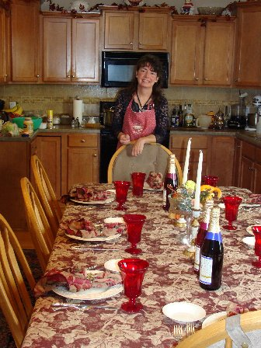
Looking forward to the arrival of the guests

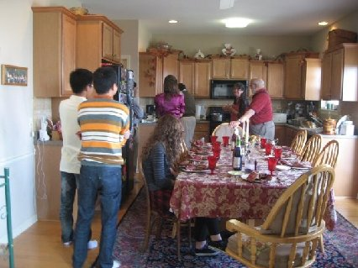
Bro. Jed cutting the bird!
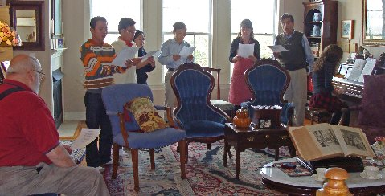
Singing the hymn, "We Gather Together,"
before the prayer.
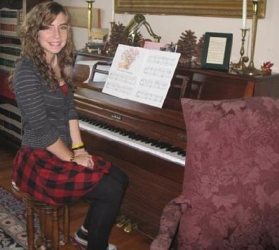
Priscilla, 15, at the piano.
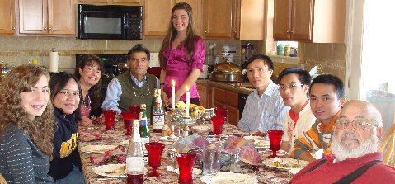
Left to Right: Priscilla, Rilya, Cindy, Jed,
Martha, Cuong, Dat, Jung and Bro Cope

